Create Node-RED Service

|  |  |
| --- | --- |
| Date | 17 November 2022 |
| Team ID | PNT2022TMID14561 |
| Project Name | Project – Smart Farmer-IoT Enabled smart Farming Application |

Steps for creating Node-RED Service

# Find the Node-RED Starter Kit in the IBM Cloud catalog.

1. Create your application.
2. Enable the Continuous Delivery feature.
3. Open the Node-RED application.
4. Configure your Node-RED application.
5. Add extra nodes to your Node-RED palette

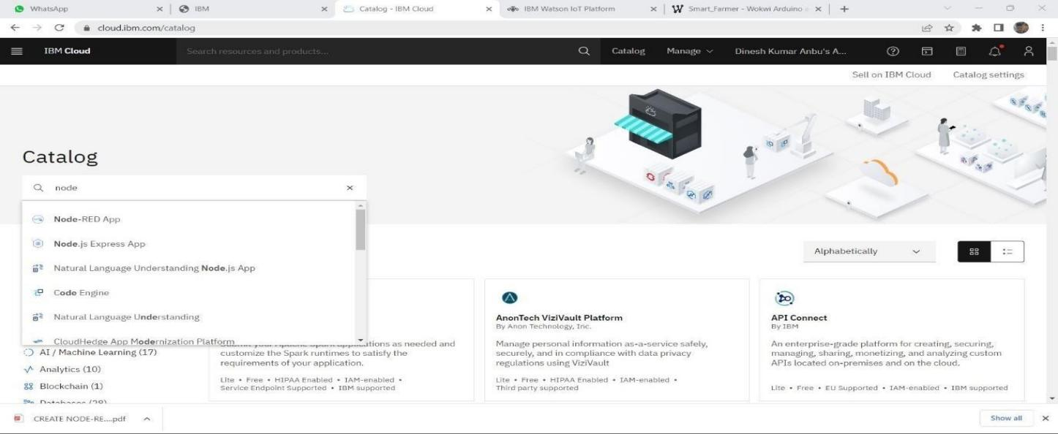

STEP 1: Find the Node-RED Starter Kit In The IBM Cloud Catalog

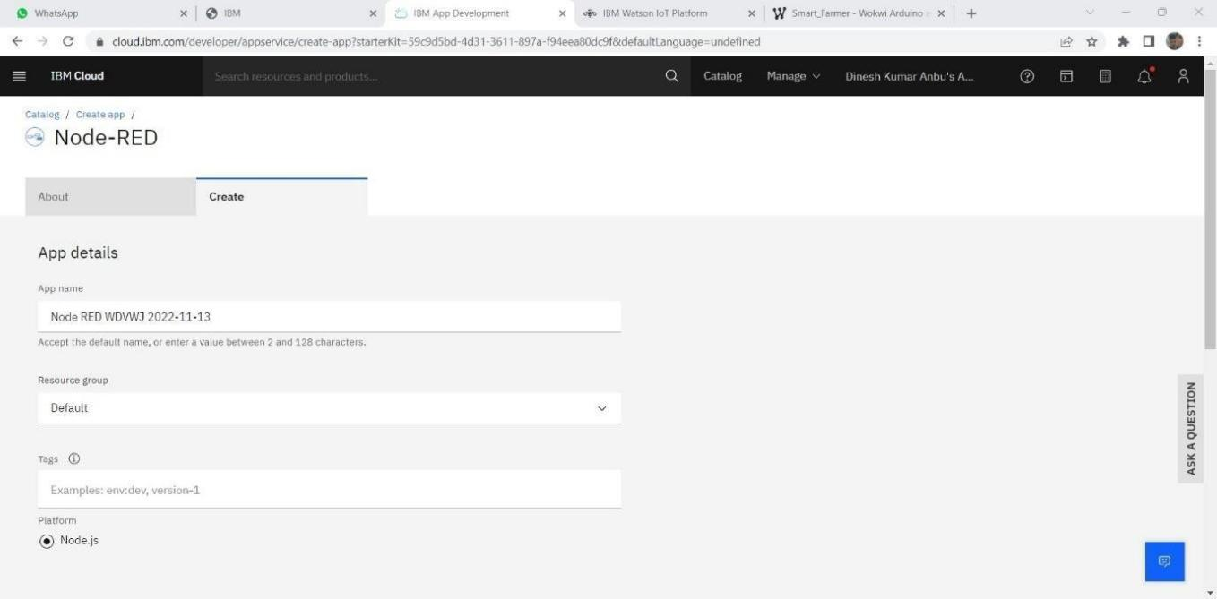

STEP 2: Create Your Application

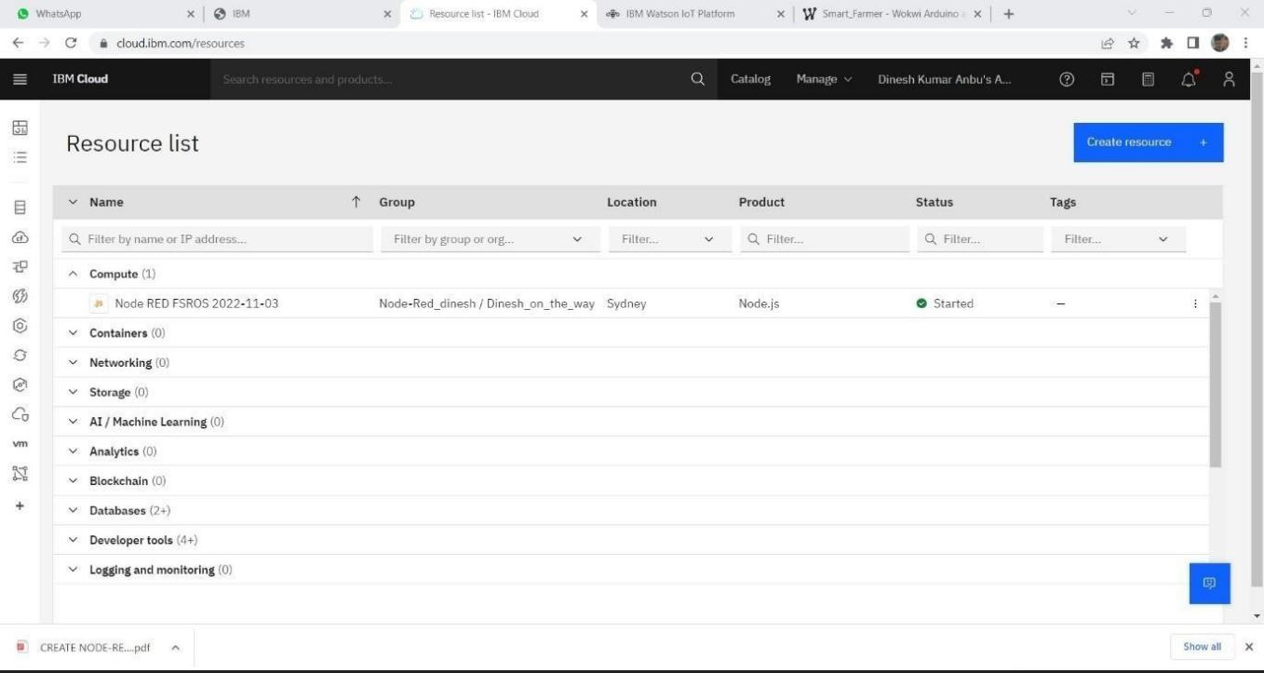

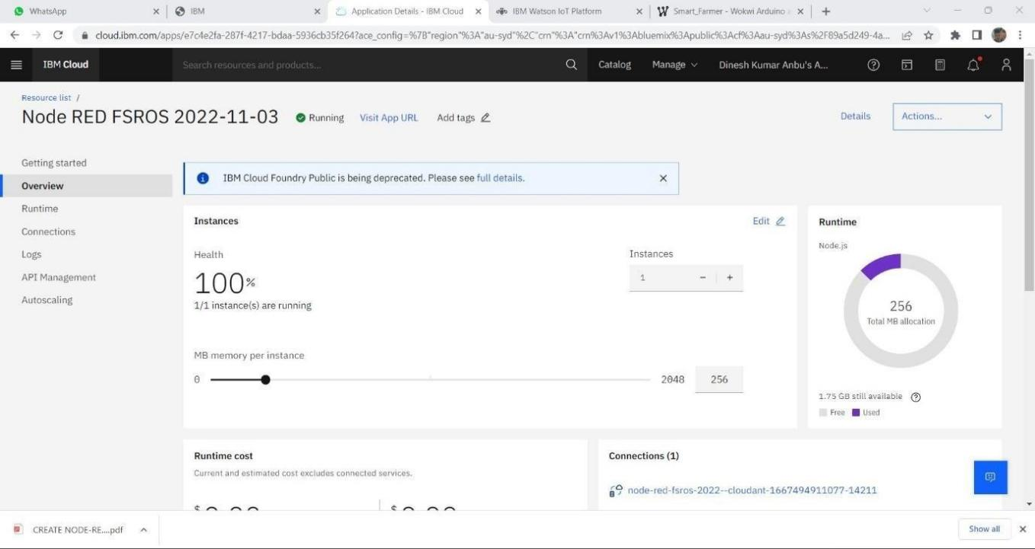

STEP 4: Open the Node-RED application

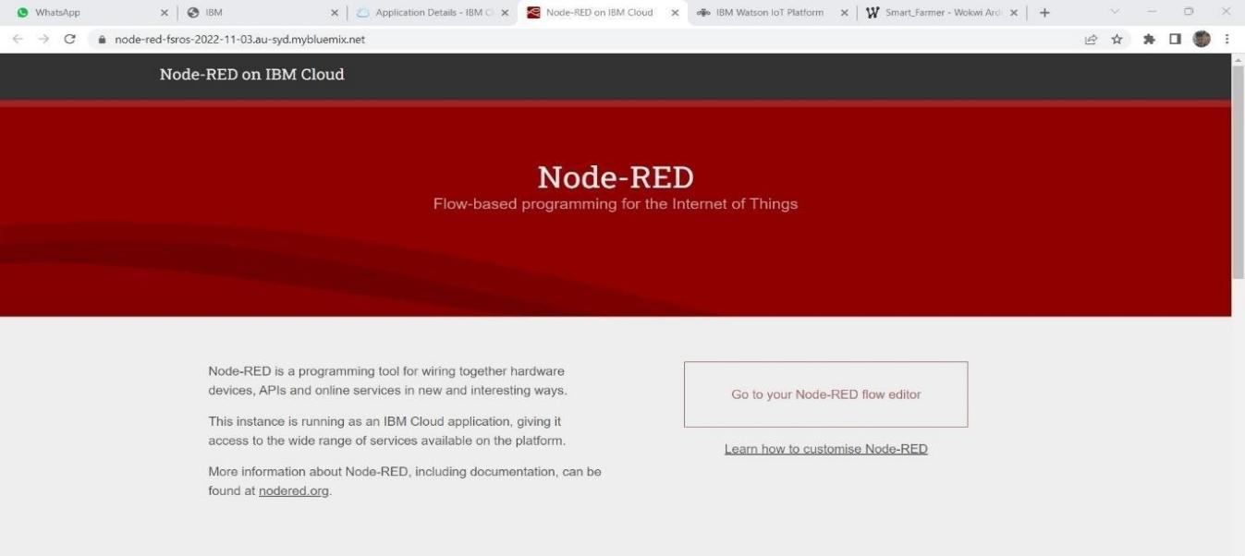

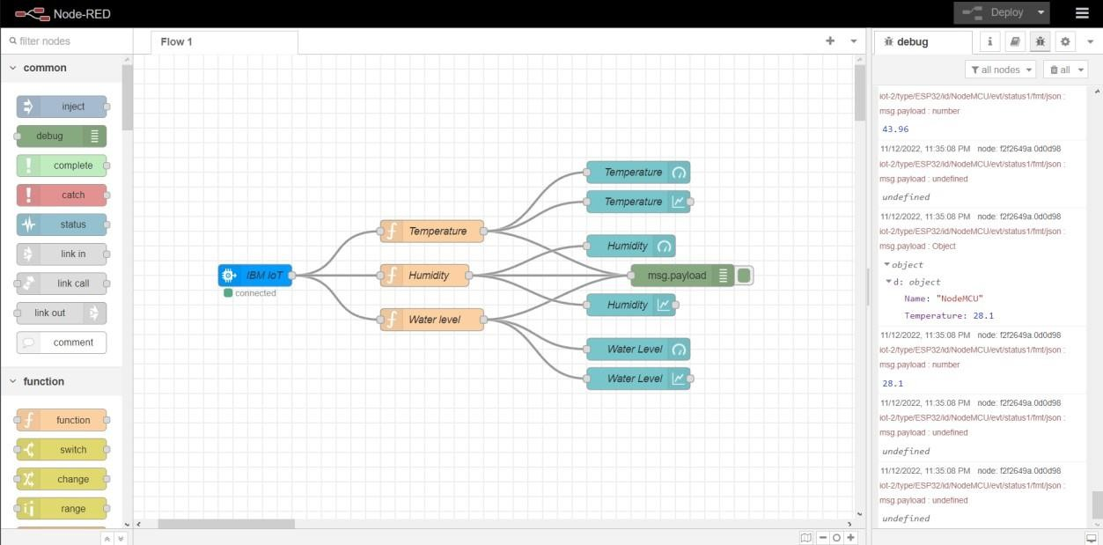

SEP 6: Configure your Node-RED application

